Device: Face Recognition Terminal

Model: K1T671MF

**#Technical Problem:**

1. **False punch issue:** We are long time faced this problem & previously we discussed with Hikvision about that several time but It’s not solve yet. Pls see the below attachment.

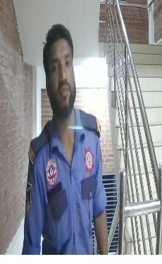

Face Punch Capture Right Picture (Authorized) ID No 461656 Wrong Picture (Unauthorized)

*Face Punch Capture Right Picture (Authorized) ID No 461656

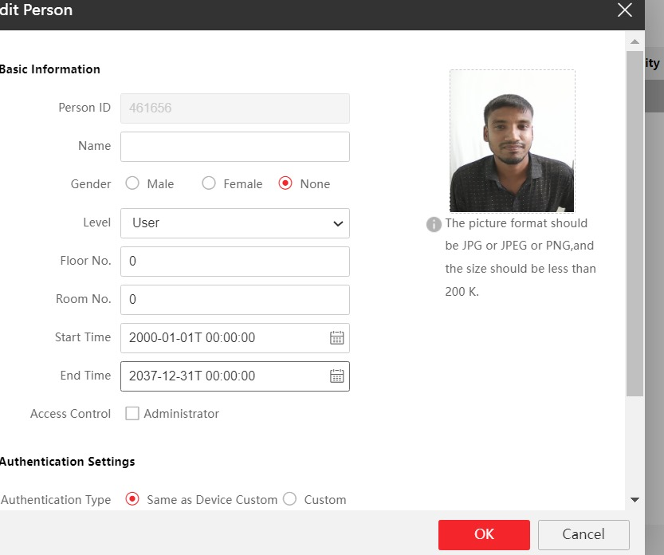

Device Settings:

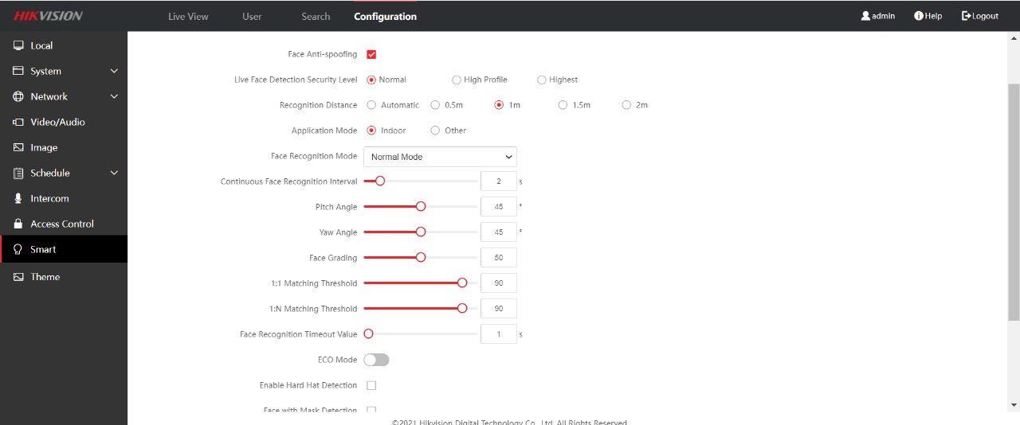

1. **Event Data clear issue:** When device is memory full then some device functionally slow work. Manually event data clear option is not in face device that’s why we can’t event data clear from face device.
2. **Overheating Issue:** The device hangs due to overheating and the fingerprint module does not work properly. After restarting the device then fingerprint module work.
3. **Time Issue:** The lithium battery of this device cannot be easily changed. It’s circuit is compact compared to other devices. So, there should be a system that can be easily changed because of some devices before install or after 3 months then time problem found.
4. **Service Delay from RMA Centre:** Need to faster service from RMA Centre otherwise we can’t managed our client.
5. **Data Download Slow Issue**: When the data download from single device then data download fast & easily but multiple device data download slowly.
6. **Data transfer issue:** When firmware upgrade then Pen derive via data transfer problem found & also different version doesn’t work data transfer by pen derive.
7. **Doc & Video:** We need Documentation for Hik central software.We also need a **Video tutorial**.